# HƯỚNG DẪN CÀI ĐẶT

### Cài đặt PostgreSQL 16

* Vào đường dẫn lựa chọn phiên bản 16.2 để tải về:

<https://www.enterprisedb.com/downloads/postgres-postgresql-downloads>

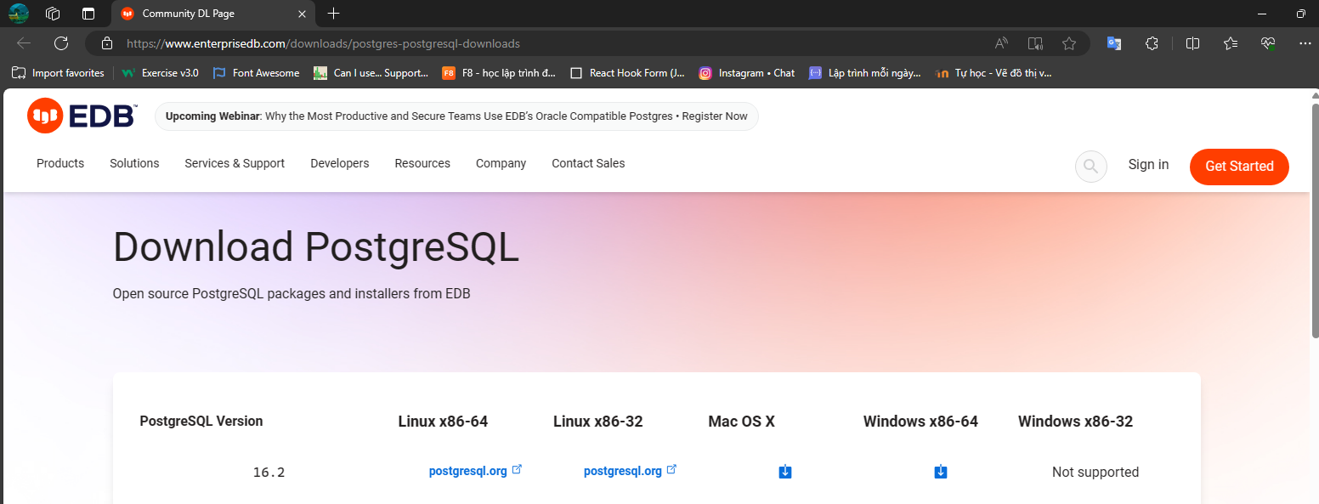

* Mở app vừa tải về để cài đặt nên đặt mật khẩu PostgreSQL là 123 để tương thích với ứng dụng.
* Sau đó tìm kiếm và mở App lên

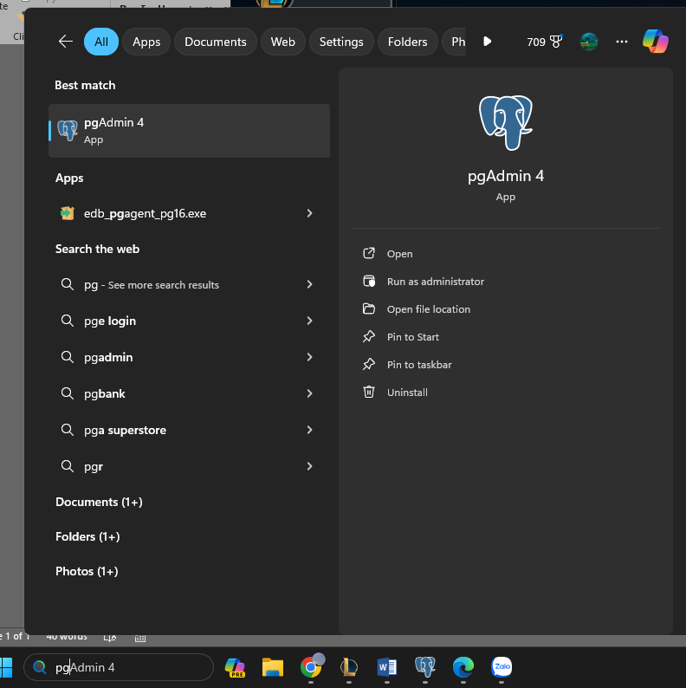

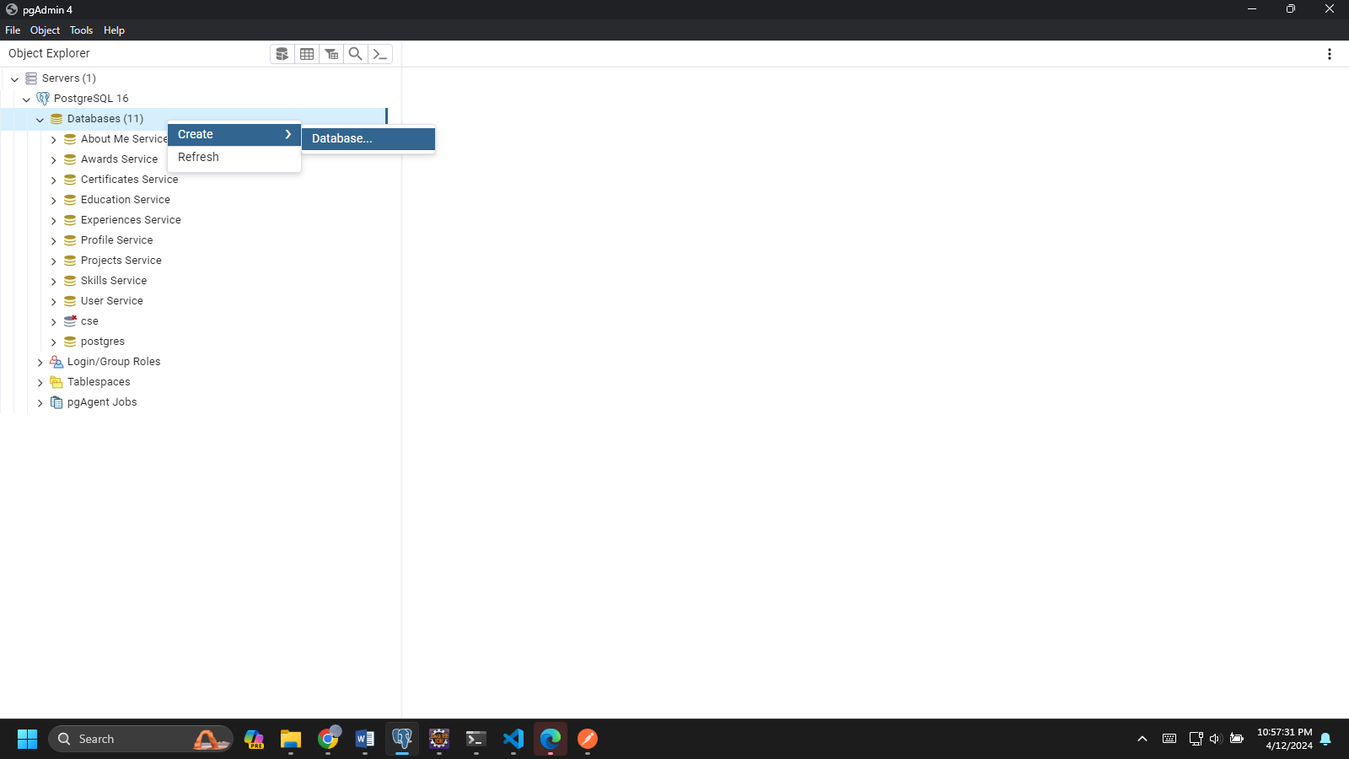

* Ở Database chọn Create Database đặt tên là User Service

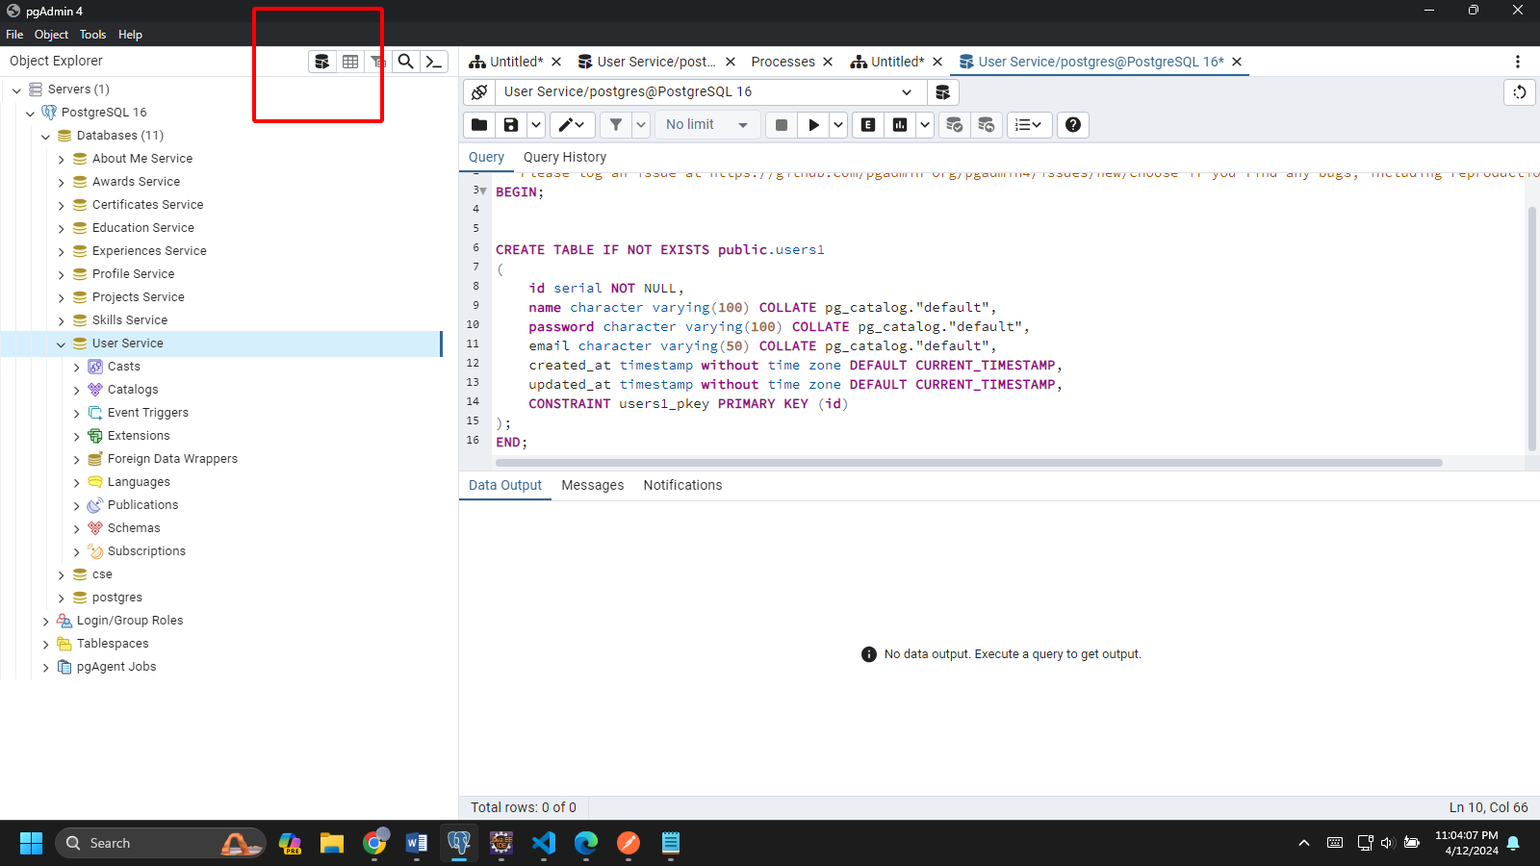

* Chọn vào nút Query tool để thực hiện lệnh Create:

-- This script was generated by the ERD tool in pgAdmin 4.

-- Please log an issue at https://github.com/pgadmin-org/pgadmin4/issues/new/choose if you find any bugs, including reproduction steps.

BEGIN;

CREATE TABLE IF NOT EXISTS public.users1

(

id serial NOT NULL,

name character varying(100) COLLATE pg_catalog."default",

password character varying(100) COLLATE pg_catalog."default",

email character varying(50) COLLATE pg_catalog."default",

created_at timestamp without time zone DEFAULT CURRENT_TIMESTAMP,

updated_at timestamp without time zone DEFAULT CURRENT_TIMESTAMP,

CONSTRAINT users1_pkey PRIMARY KEY (id)

);

END;

Thực hiện thành công

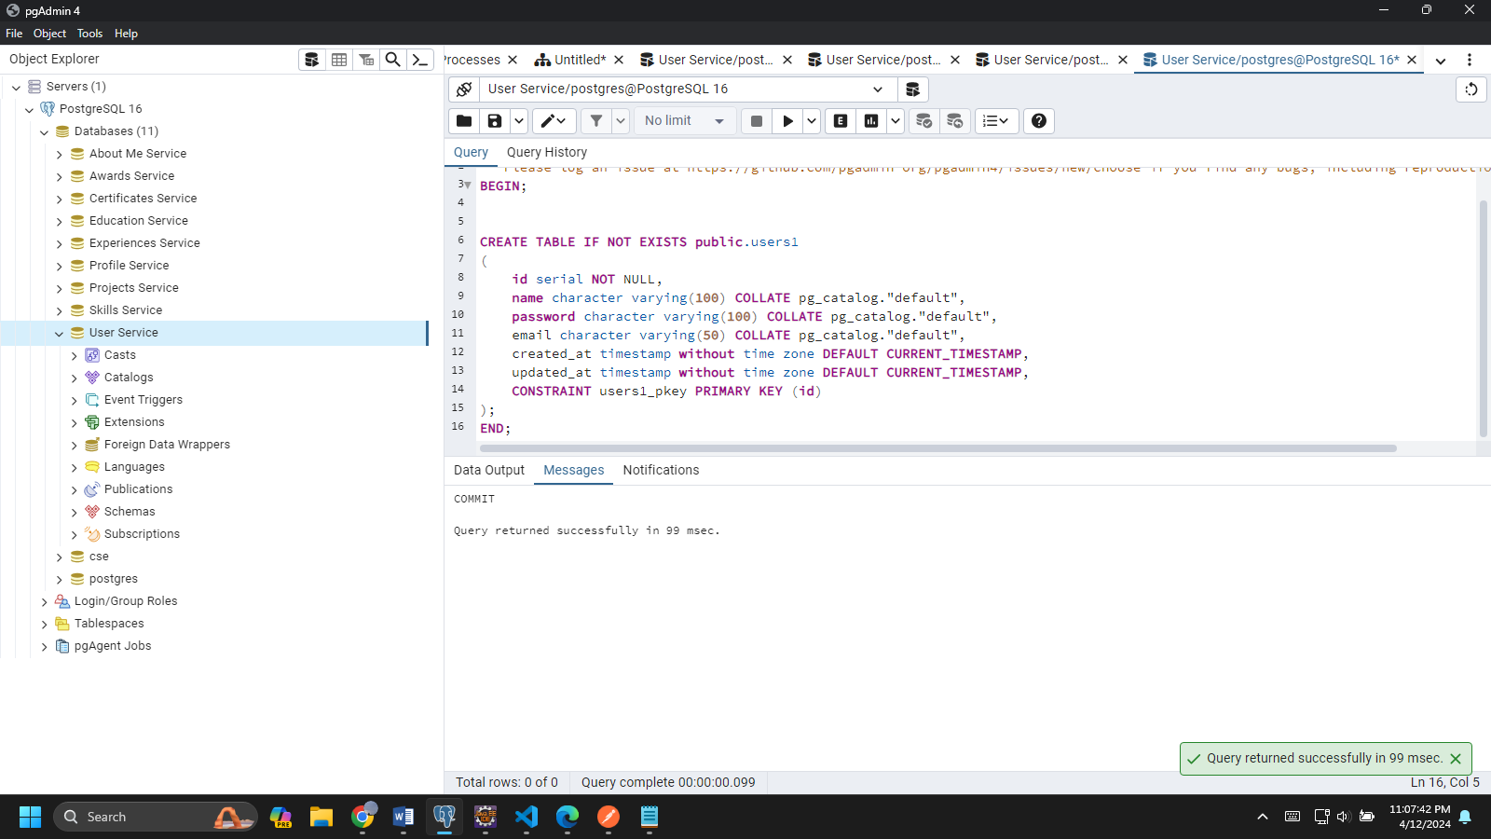

* Ở các Database khác tương tự như trên.

**Skills Service**

**-- This script was generated by the ERD tool in pgAdmin 4.**

**-- Please log an issue at https://github.com/pgadmin-org/pgadmin4/issues/new/choose if you find any bugs, including reproduction steps.**

**BEGIN;**

**CREATE TABLE IF NOT EXISTS public.skills**

**(**

**id serial NOT NULL,**

**profiles_id integer NOT NULL,**

**name character varying(70) COLLATE pg_catalog."default",**

**level integer,**

**CONSTRAINT skills_pkey PRIMARY KEY (id)**

**);**

**END;**

**Projects Service**

**-- This script was generated by the ERD tool in pgAdmin 4.**

**-- Please log an issue at https://github.com/pgadmin-org/pgadmin4/issues/new/choose if you find any bugs, including reproduction steps.**

**BEGIN;**

**CREATE TABLE IF NOT EXISTS public.projects**

**(**

**id serial NOT NULL,**

**title character varying(100) COLLATE pg_catalog."default",**

**description text COLLATE pg_catalog."default",**

**profiles_id bigint,**

**start_date text COLLATE pg_catalog."default",**

**end_date text COLLATE pg_catalog."default",**

**CONSTRAINT projects_pkey PRIMARY KEY (id)**

**);**

**END;**

**Profile Service**

**-- This script was generated by the ERD tool in pgAdmin 4.**

**-- Please log an issue at https://github.com/pgadmin-org/pgadmin4/issues/new/choose if you find any bugs, including reproduction steps.**

**BEGIN;**

**CREATE TABLE IF NOT EXISTS public.profiles**

**(**

**id bigserial NOT NULL,**

**users_id bigint NOT NULL,**

**name character varying(100) COLLATE pg_catalog."default",**

**title character varying(100) COLLATE pg_catalog."default",**

**phone character varying(20) COLLATE pg_catalog."default",**

**email character varying(50) COLLATE pg_catalog."default",**

**image text COLLATE pg_catalog."default",**

**gender boolean,**

**location text COLLATE pg_catalog."default",**

**website character varying(100) COLLATE pg_catalog."default",**

**birthday text COLLATE pg_catalog."default",**

**CONSTRAINT profiles_pkey PRIMARY KEY (id)**

**);**

**END;**

**Experiences Service**

**-- This script was generated by the ERD tool in pgAdmin 4.**

**-- Please log an issue at https://github.com/pgadmin-org/pgadmin4/issues/new/choose if you find any bugs, including reproduction steps.**

**BEGIN;**

**CREATE TABLE IF NOT EXISTS public.experiences**

**(**

**id serial NOT NULL,**

**"position" character varying(255) COLLATE pg_catalog."default",**

**company character varying(255) COLLATE pg_catalog."default",**

**responsibilities character varying(255) COLLATE pg_catalog."default",**

**start_date character varying(255) COLLATE pg_catalog."default",**

**end_date character varying(255) COLLATE pg_catalog."default",**

**profiles_id bigint,**

**CONSTRAINT experiences_pkey PRIMARY KEY (id)**

**);**

**END;**

**Education Service**

**-- This script was generated by the ERD tool in pgAdmin 4.**

**-- Please log an issue at https://github.com/pgadmin-org/pgadmin4/issues/new/choose if you find any bugs, including reproduction steps.**

**BEGIN;**

**CREATE TABLE IF NOT EXISTS public.educations**

**(**

**id serial NOT NULL,**

**degree character varying(100) COLLATE pg_catalog."default",**

**institution character varying(100) COLLATE pg_catalog."default",**

**additionaldetail character varying(100) COLLATE pg_catalog."default",**

**start_date text COLLATE pg_catalog."default",**

**end_date text COLLATE pg_catalog."default",**

**profiles_id bigint,**

**CONSTRAINT educations_pkey PRIMARY KEY (id)**

**);**

**END;**

**Certificates Service**

**-- This script was generated by the ERD tool in pgAdmin 4.**

**-- Please log an issue at https://github.com/pgadmin-org/pgadmin4/issues/new/choose if you find any bugs, including reproduction steps.**

**BEGIN;**

**CREATE TABLE IF NOT EXISTS public.certificates**

**(**

**id serial NOT NULL,**

**profiles_id bigint,**

**title character varying COLLATE pg_catalog."default",**

**provider character varying COLLATE pg_catalog."default",**

**description character varying COLLATE pg_catalog."default",**

**certificateurl character varying COLLATE pg_catalog."default",**

**issuedate text COLLATE pg_catalog."default",**

**CONSTRAINT certificates_pkey PRIMARY KEY (id)**

**);**

**END;**

**Awards Service**

**-- This script was generated by the ERD tool in pgAdmin 4.**

**-- Please log an issue at https://github.com/pgadmin-org/pgadmin4/issues/new/choose if you find any bugs, including reproduction steps.**

**BEGIN;**

**CREATE TABLE IF NOT EXISTS public.awards**

**(**

**id serial NOT NULL,**

**profiles_id integer,**

**title character varying COLLATE pg_catalog."default",**

**provider character varying COLLATE pg_catalog."default",**

**description text COLLATE pg_catalog."default",**

**issuedate text COLLATE pg_catalog."default",**

**CONSTRAINT awards_pkey PRIMARY KEY (id)**

**);**

**END;**

**About Me Service**

**-- This script was generated by the ERD tool in pgAdmin 4.**

**-- Please log an issue at https://github.com/pgadmin-org/pgadmin4/issues/new/choose if you find any bugs, including reproduction steps.**

**BEGIN;**

**CREATE TABLE IF NOT EXISTS public.aboutme**

**(**

**id serial NOT NULL,**

**profiles_id integer NOT NULL,**

**description text COLLATE pg_catalog."default",**

**CONSTRAINT aboutme_pkey PRIMARY KEY (id)**

**);**

**END;**

### Cài đặt BackEnd

* Mở thư mục Project BackEnd đã giải nén lên:

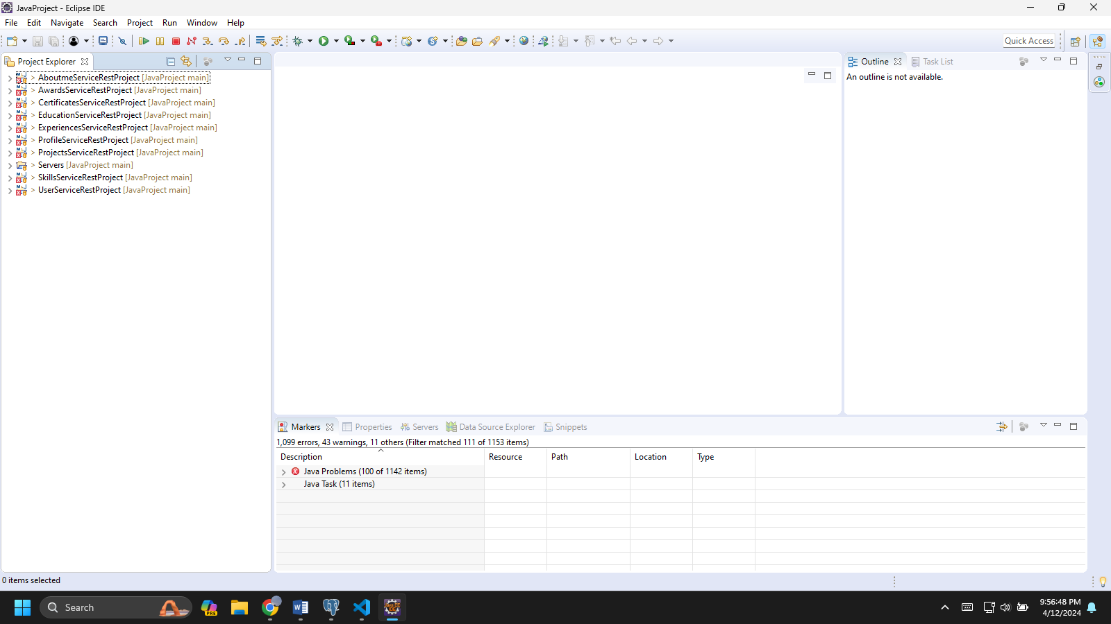

* Thêm thư viện JAX-RS Jersey vào
* Sau đó cấu hình Sever Tomcat

### Cài đặt FrontEnd

* Mở thư mục FrontEnd đã giải nén lên:
* Chạy Terminal câu lệnh: **npm install**

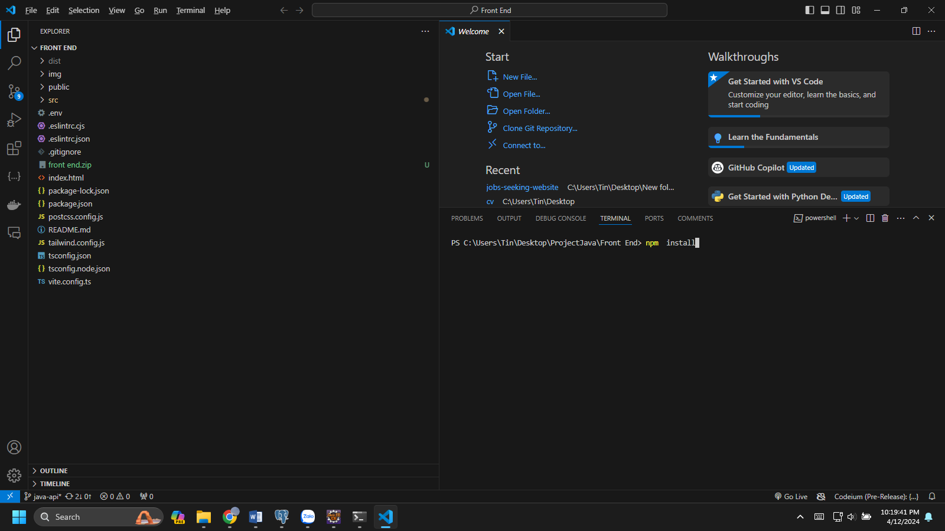

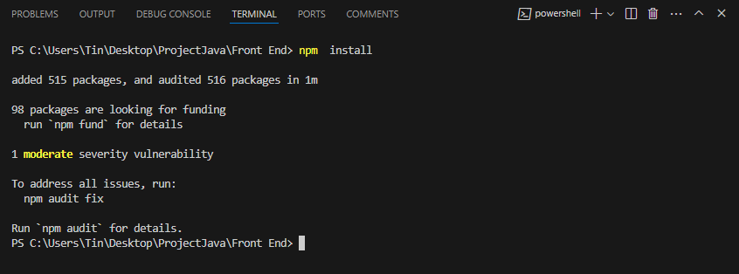

* Đã Build xong Project.
* Chạy lệnh: **npm run dev** để chạy Front End

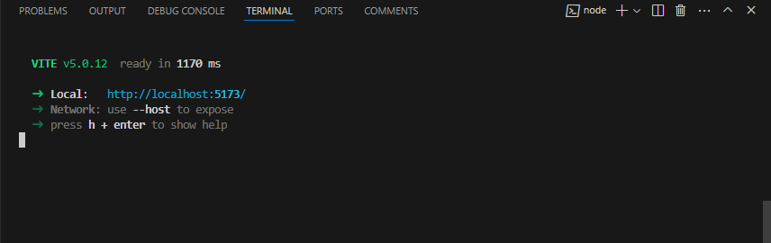

* Ấn vào địa chỉ để vào Web